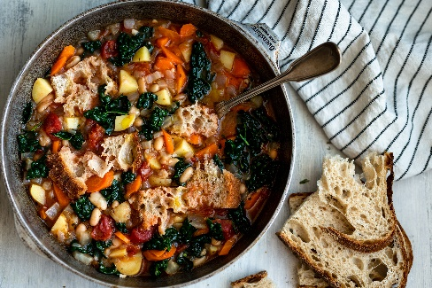
RIBOLLITA WITH ROOT VEGETABLES AND CRUSTY BREAD (VEGAN)
Kate Hendricks
Keeping with this year’s theme of Roots and Grains, we have added potatoes and turnips to this traditional, hearty Tuscan soup. And remember, save that stale bread to sop up the delicious broth.

Ingredients
1 onion, diced
2 carrots, diced
2 celery stalks, diced
3 cloves garlic, minced
2 potatoes, peeled and diced
2 turnips, peeled and diced
1 can (14 oz) cannellini beans, drained and rinsed
1 can (14 oz) diced tomatoes
4 cups vegetable broth
2 cups water
2 cups kale or spinach, chopped
1 teaspoon dried thyme
1 teaspoon dried rosemary
1 bay leaf
Salt and pepper to taste
Olive oil
Crusty bread (stale preferred) cut into bite-sized chunks

Instructions
- In a large pot, heat olive oil over medium heat. Add the diced onion, carrots, and celery. Cook until softened, about 5-7 minutes.
- Add the minced garlic and cook for another minute until fragrant.
- Stir in the diced potatoes, diced turnips, cannellini beans, vegetable broth, water, thyme, rosemary, bay leaf, salt, and pepper. Bring the soup to a boil, then reduce the heat to low and let it simmer for about 20-25 minutes, or until the potatoes are tender.
- Once the potatoes and turnips are cooked, add the chopped kale or spinach to the pot and cook for an additional 5 minutes until wilted.
- Taste and adjust the seasoning if necessary.
- To serve, place chunks of crusty bread in each bowl and ladle the soup over the top. Let the soup sit for a few minutes to allow the bread to soak up some of the broth. Drizzle with a little good olive oil.

